SIMATS ENGINEERING (SAVEETHA SCHOOL OF ENGINEERING)
Department of Computer Science and Engineering
ASSESSMENT TOOL 1 – Coding Challenge Task
Course Code: | CSA06 |  | Course Title: | Design and Analysis of Algorithms
CO Assessed: | CO4: Articulation (BL4, BL5) |  | Assessment: | Assessment Tool 1 – Coding Challenge Task
Weightage: | 40% of CIA |  | Total Marks: | 100 (2 Questions × 50 Marks)
CO4 Statement: | Solve optimization problems using dynamic programming and greedy strategies.
Student Name: | Lella Thannveer Reddy |  | Reg. No.: | 192524293
Section / Batch: | SLOT - A |  | Date: | 21/08/2026
Instructions to Students
- Answer both questions. Each question carries 50 Marks. Total: 100 Marks.
- Carefully analyze the given questions.
- Write clear code for the given problem.
- Analyze the Time complexity and Space complexity of your code using dynamic programming and greedy strategies
Question Type |  | Description |  |  | Questions | Total Marks
Coding Challenge Task |  | Focus on Code and analyze optimization problems using dynamic programming and greedy strategies |  |  | Q1 – Q2 | 100

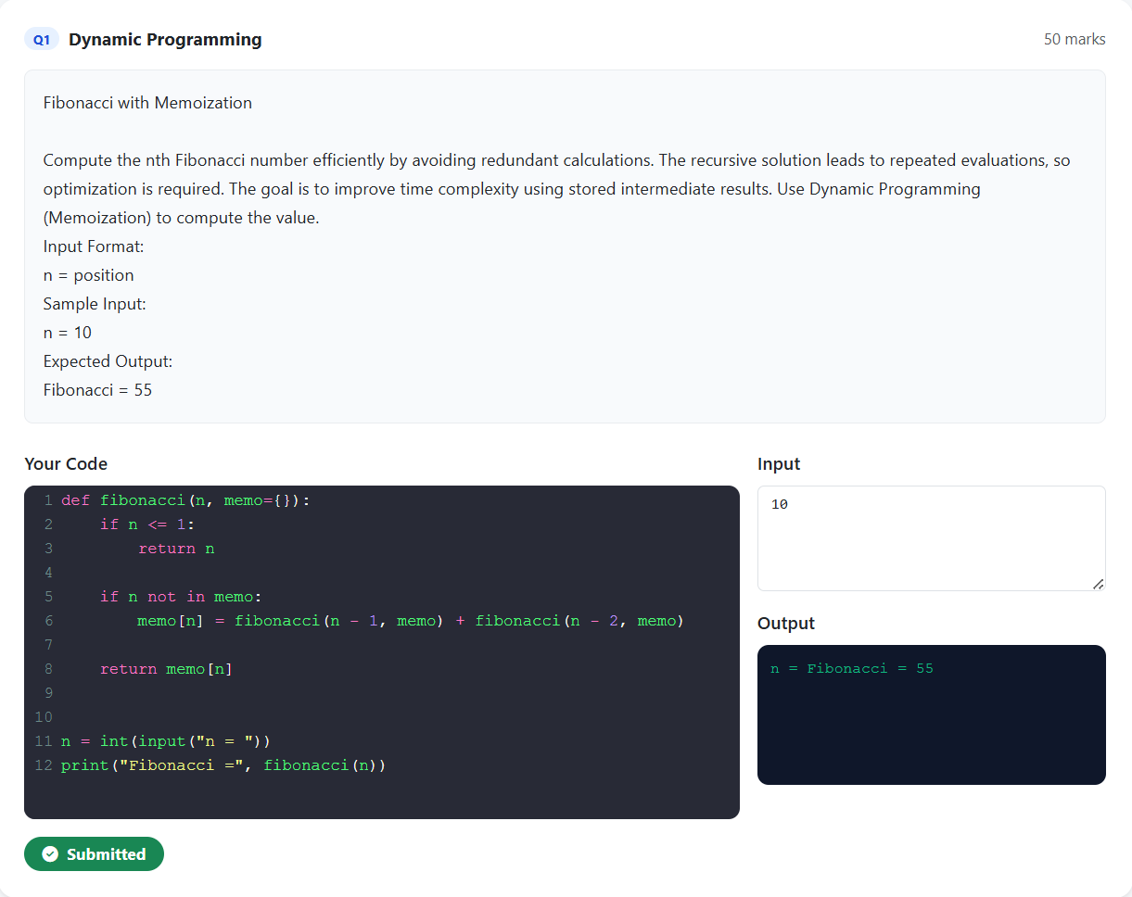

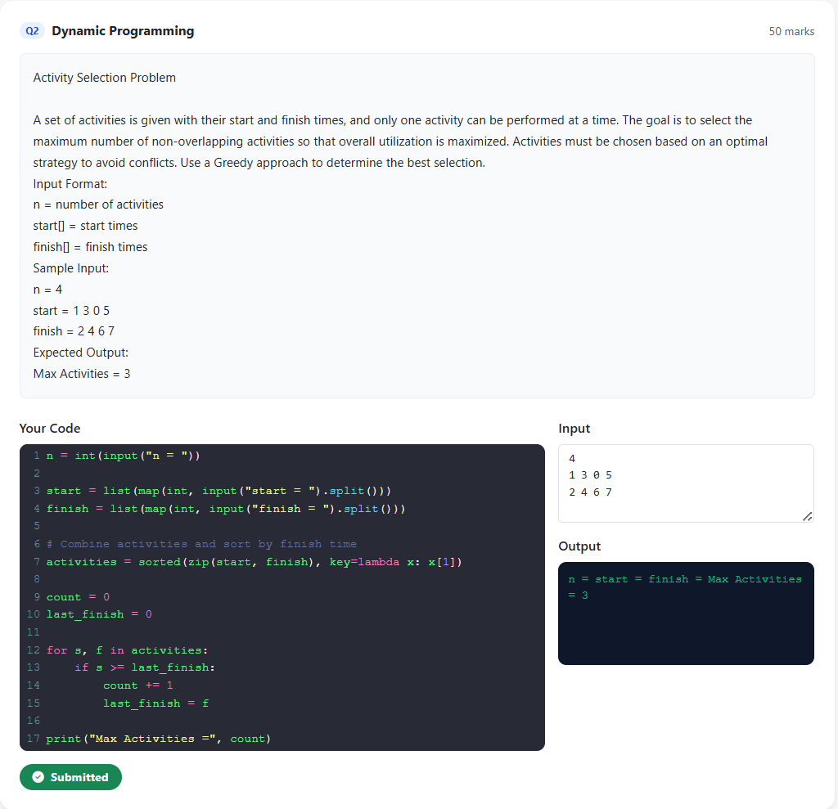

RUBRICS FOR CALCULATION

Coding Challenge Task
Criteria | Weightage | Level 4 (Exemplary) | Level 3 (Proficient) | Level 2 (Developing) | Level 1 (Beginning)
Problem Understanding | 20% | Clearly understands problem constraints, edge cases, and competitive requirements | Understands problem with  minor gaps in  constraints | Partial understanding; misses key constraints | Misinterprets problem or constraints
Algorithm | 25% | Selects optimal algorithm with best time and space complexity for  competitive constraints | Uses efficient algorithm with  minor scope for improvement | Uses basic/inefficient approach | No clear algorithmic approach
Code Implementation | 20% | Writes correct, efficient, and clean  code that passes all constraints | Code works with minor errors or inefficiencies | Partially correct code; fails for some  cases | Code does not execute or gives incorrect results
Competitive Performance | 20% | Solves problem within time limits and  handles large inputs effectively | Solves within acceptable time with minor delays | Struggles with time limits or larger inputs | Unable to solve within time constraints
Test Case  Handling | 15% | Handles all test cases including edge and hidden cases | Handles most test cases | Misses important edge cases | Fails on multiple test cases
SECTION A – Coding Challenge Task
Code of Conduct
I _Lella Thannveer Reddy/192524293_ (Name / Reg No) certify that this submission is my original work and that I have adhered to the guidelines specified for this assessment. I understand that any violation of academic integrity rules will result in disciplinary action.
Faculty In-charge | Course Coordinator | Head of Department
Name: __________________  Signature: _______________ | Signature: _______________ | Signature: _______________
Date: ___________________ | Date: ___________________ | Date: ___________________
Signature of the Student: 
Questions | Problem  Understandin  g (20) | Algorith m (25) | Code  Implementatio n  (20) | Competitive  Performance  (20) | Test  Case  Handlin g  (15) | Total  Marks  (Each - 50)
Q1
Q2
 |  |  |  | Overall Total
Mark Evaluation

